Name

Mathematics Advanced Year 12
Differentiating Logarithmic Functions

Book 2 |  | Version: 251202  Feedback:  https://MrDingMaths.com
Contents
Syllabus Content 2
Learning Intention 3

Syllabus Content
MAV-12-04 selects and applies differentiation methods to solve problems
Differentiation with logarithmic functions
- Use chain rule on the identity $e^{\ln{x}}=x$ to prove the formula $\frac{d}{dx}\left(\ln{x}\right)=\frac{1}{x}$ for the derivative of the natural logarithm function where $x>0$
- Prove and use the formula $\frac{d}{dx}\left(\log_{a}x\right)=\frac{1}{x\ln{a}}$, where $a$ is a constant and $a>0$
- Use the chain rule to differentiate functions of the form $\ln{f\left(x\right)}$

Derivative of Natural Logarithmic Functions

- Investigation Derivative of natural logarithmic functions.
In this investigation we will derive the derivative of $y=\ln{x}$
We will start with $y=e^{\ln{x}},$ differentiate by letting $u=\ln{x}:$
$$y=e^{\ln{x}}$$
$$\frac{dy}{dx}=\frac{dy}{du}×\frac{du}{dx}$$
Let $u=\ln{x}$
$$\frac{du}{dx}=u^{'}\left(x\right)$$
(where $u^{'}\left(x\right)$ is the derivative of $\ln{x}$, which we want to find)

Let $y=e^{u}$
$$\frac{dy}{du}=$$

Now, we apply the identity $e^{\ln{x}}=x$.
From above, we can rewrite:  $$\frac{dy}{dx}=u^{'}\left(x\right)e^{\ln{x}}$$  $=$ | And at the same time, using $y=e^{\ln{x}}=x$,  $$\frac{dy}{dx}=$$

Equating the two expressions we have for $\frac{dy}{dx},$ we can find an expression for $u'\left(x\right),$ which is the derivative of $\ln{x}$.

- Derivative of Natural Logarithmic Function
$$f\left(x\right)=\ln{x} \\ f^{'}\left(x\right)=\frac{1}{x}$$

- Identify the derivative of a logarithmic function.
$f\left(x\right)=2\ln{x}$  $$f^{'}\left(x\right)=2×\frac{1}{x}$$  $$=\frac{2}{x}$$ | $f\left(x\right)=x^{2}+\ln{x}$  $$f^{'}\left(x\right)=2x+\frac{1}{x}$$ | $$f\left(x\right)=5x^{2}-3\ln{x}$$  $$f^{'}\left(x\right)=10x-\frac{3}{x}$$
Differentiate these functions.
- $f\left(x\right)=5\ln{x}$ | - $f\left(x\right)=-5\ln{x}$ | - $f\left(x\right)=x-5\ln{x}$
- $f\left(x\right)=3-5\ln{x}$ | - $f\left(x\right)=x^{3}-5\ln{x}$ | - $f\left(x\right)=7x^{2}+12\ln{x}$

- Investigation Chain rule for logarithmic functions.
Consider $y=\ln\left(f\left(x\right)\right)$.
Using chain rule, find the general form of the derivative.
$$y=\ln\left(f\left(x\right)\right)$$
$$\frac{dy}{dx}=\frac{dy}{du}×\frac{du}{dx}$$
Let $u=f\left(x\right)$
$$\frac{du}{dx}=$$

Let $y=\ln{u}$
$$\frac{dy}{du}=$$

- Chain Rule for Natural Logarithmic Function
$$y=\ln{f\left(x\right)} \\ \frac{dy}{dx}=\frac{f^{'}\left(x\right)}{f\left(x\right)}$$

- Identify the derivative of a logarithmic function.
$f\left(x\right)=\ln\left(7x\right)$  $$f^{'}\left(x\right)=\frac{7}{7x}$$  $$=\frac{1}{x}$$ | $f\left(x\right)=\ln\left(x^{2}\right)$  $$f^{'}\left(x\right)=\frac{2x}{x^{2}}$$  $$=\frac{2}{x}$$ | $$f\left(x\right)=\ln\left(3x^{5}+7x\right)$$  $$f^{'}\left(x\right)=\frac{15x^{4}+7}{3x^{5}+7x}$$
Explain why the derivative of $\ln\left(7x\right)$is the same as the derivative of $\ln\left(x\right)$.

Explain why the derivative of $\ln\left(x^{2}\right)$is the same as the derivative of $2\ln\left(x\right)$.

Differentiate these functions.
- $f\left(x\right)=\ln{7x}$ | - $f\left(x\right)=\ln{7 }+\ln{x}$ | - $f\left(x\right)=\ln\left(5x^{2}\right)$
- $f\left(x\right)=\ln\left(\frac{5}{x}\right)$ | - $f\left(x\right)=\ln\left(\sqrt{x}\right)$ | - $f\left(x\right)=\ln\left(11x^{3}-7x^{2}\right)$

- The Log Laws
Inverse Relationship | ${\log_{a}{a}}^{x}=a^{\log_{a}{x}}=x$
Log Law of Multiplication | $$\log_{a}\left(xy\right)=\log_{a}{x}+\log_{a}{y}$$
Log Law of Division | $$\log_{a}\left(\frac{x}{y}\right)=\log_{a}{x}-\log_{a}{y}$$
Log Law of Indices | $$\log_{a}{(x^{n})}=n\log_{a}{x}$$

- Investigation using log laws to simplify before you differentiate.
We can use log laws to change complex logarithms to multiples or sums of simpler logs.
Simplify, then differentiate these functions.
- $f\left(x\right)=\ln{(7x^{2}})$ | - $f\left(x\right)=\ln\left({\left(3x-7\right)}^{5}\right)$
- $f\left(x\right)=\ln\left(x^{3}\right)$  - $f\left(x\right)={\left(\ln{x}\right)}^{3}$ | - $f\left(x\right)=$ $\ln\left(\frac{1+x}{1-x }\right)$  - $f\left(x\right)=$ $\frac{\ln\left(1+x\right)}{1-x}$

- Example Differentiate natural logarithmic functions.
Differentiate  $y=x^{3}\ln{x}$ use product rule  $$y^{'}=u^{'}v+uv^{'}$$  $$=3x^{2}\ln{x}+x^{3}⋅\frac{1}{x}$$  $$=x^{2}\left(3\ln{x}+1\right)$$ | Differentiate  $y=$ $\frac{\ln\left(1+x\right)}{x}$ use quotient rule  $$y^{'}=\frac{u^{'}v-uv^{'}}{v^{2}}$$  $$=\frac{\frac{1}{1+x}\left(x\right)-\ln\left(1+x\right)\left(1\right)}{x^{2}}$$  $$=\frac{\frac{x}{1+x}-\ln\left(1+x\right)}{x^{2}}$$  $$=\frac{x-\left(1+x\right)\ln\left(1+x\right)}{x^{2}\left(1+x\right)}$$

- Practice
Differentiate  $$y=x^{4}\ln{x}$$  $$x^{3}\left(4\ln{x}+1\right)$$ | Differentiate  $$y=\frac{\ln\left(2x\right)}{x^{3}}$$  $$\frac{1-3\ln\left(2x\right)}{x^{4}}$$
Differentiate  $$y={\left(\ln\left(x\right)+x\right)}^{5}$$  $$5{\left(x+\ln{(x)}\right)}^{4}\left(\frac{1+x}{x}\right)$$ | Differentiate  $$y=\frac{3x}{\ln{x}}$$  $$\frac{3\left(\ln{x}-1\right)}{{\left(\ln{x}\right)}^{2}}$$

Foundation
- Differentiate:
- $y = log_{e}\left(x + 2\right)$  $$y^{'}=\frac{1}{x + 2}$$ | - $y = log_{e}(x - 3)$  $$y^{'}=\frac{1}{x - 3}$$ | - $y = log_{e}(3x + 4)$  $$y^{'}=\frac{3}{3x + 4}$$
- $y = log_{e}(2x - 1)$  $$y^{'}=\frac{2}{2x - 1}$$ | - $y = log_{e}(-4x + 1)$  $$y' = -\frac{4}{-4x + 1}$$ | - $y = log_{e}(-3x + 4)$  $$y' = -\frac{3}{-3x + 4}$$
- $y = ln(-2x - 7)$  $$y^{'}= -\frac{2}{-2x - 7}=\frac{2}{2x + 7}$$ | - $y = 3 ln(2x + 4)$  $$y^{'}= 3\left(\frac{2}{2x + 4}\right)=\frac{6}{2x + 4}=\frac{3}{x + 2}$$ | - $y = 5 ln(3x - 2)$  $$y^{'}= 5\left(\frac{3}{3x - 2}\right)=\frac{15}{3x - 2}$$
- $y = ln 2x$  $$y^{'}=\frac{1}{x}$$ | - $y = ln 5x$  $$y^{'}=\frac{1}{x}$$ | - $y = ln 7x$  $$y^{'}=\frac{1}{x}$$
- $y = 4 ln 7x$  $$y^{'}=\frac{4}{x}$$ | - $y = 3 ln 5x$  $$y^{'}=\frac{3}{x}$$ | - $y = 4 ln 6x$  $$y^{'}=\frac{4}{x}$$

- Find $\frac{dy}{dx}$ for each function. Then evaluate $\frac{dy}{dx}$ at $x = 3$.
- $y = log_{e}(2x - 1)$  $$y^{'}=\frac{2}{2x - 1},$$  $$y^{'}\left(3\right)=\frac{2}{5}$$ | - $y = log_{e}(4x + 3)$  $$y^{'}=\frac{4}{4x + 3},$$  $$y^{'}\left(3\right)=\frac{4}{15}$$ | - $y = 6 ln(2x + 9)$  $$y^{'}=\frac{12}{2x + 9},$$  $$y^{'}\left(3\right)=\frac{4}{5}$$

- Differentiate these functions.
- $2 + log_{e} x$  $$\frac{1}{x}$$ | - $5 - log_{e}(x + 1)$  $$-\frac{1}{x + 1}$$ | - $x + 4 log_{e} x$  $$1 +\frac{4}{x}$$
- $2x^{4}+ 1 + 3 log_{e} x$  $$8x^{3}+\frac{3}{x}$$ | - $ln(2x - 1) + 3x²$  $$\frac{2}{2x - 1}+ 6x$$ | - $x³-3x+4+ln\left(5x-7\right)$  $$3x^{2}- 3 +\frac{5}{5x - 7}$$

Development
- Use the log laws to simplify each function, then differentiate it.
- $y = ln x³$  $$y = 3\ln{x},$$  $$y^{'}=\frac{3}{x}$$ | - $y = ln x²$  $$y = 2\ln{x},$$  $$y^{'}=\frac{2}{x}$$ | - $y = ln x^{-3}$  $$y = -3\ln{x},$$  $$y' = -\frac{3}{x}$$
- $y = ln x^{-2}$  $$y = -2\ln{x},$$  $$y' = -\frac{2}{x}$$ | - $y = ln \sqrt{x}$  $$y =\frac{1}{2}\ln{x},$$  $$y^{'}=\frac{1}{2x}$$ | - $y = ln \sqrt{x}+ 1$  $$y =\frac{1}{2}ln\left(x + 1\right),$$  $$y^{'}=\frac{1}{2\left(x + 1\right)}$$

- Differentiate these functions.
- $y = log_{e}\frac{x}{2}$  $$\frac{1}{x}$$ | - $y = log_{e}\frac{x}{3}$  $$\frac{1}{x}$$ | - $y = 3 log_{e}\frac{x}{5}$  $$\frac{3}{x}$$
- $y = -6 log_{e}\frac{x}{5}$  $$-\frac{6}{x}$$ | - $y = x + log_{e}\left(\frac{1}{3}x\right)$  $$1 +\frac{1}{x}$$ | - $y = 4x^{3}- log_{e}\left(\frac{1}{5}x\right)$  $$12x^{2}-\frac{1}{x}$$

- Use chain rule to differentiate:
- $ln(x² + 1)$  $$\frac{dy}{dx}=\frac{2x}{x^{2}+ 1}$$ | - $ln(2 - x²)$  $$\frac{dy}{dx}=\frac{-2x}{2 - x^{2}}$$ | - $ln(1 + eˣ)$  $$\frac{dy}{dx}=\frac{eˣ}{1 + eˣ}$$
- $log_{e}(x² + 3x + 2)$  $$\frac{2x + 3}{x^{2}+ 3x + 2}$$ | - $log_{e}(1 + 2x³)$  $$\frac{6x^{2}}{1 + 2x^{3}}$$ | - $ln(eˣ - 2)$  $$\frac{eˣ}{eˣ - 2}$$
- $x + 3 - ln(x² + x)$  $$1 -\frac{2x + 1}{x^{2}+ x}$$ | - $x² + ln(x³ - x)$  $$2x +\frac{3x^{2}- 1}{x^{3}- x}$$ | - $4x^{3}-ln(2x²-3x+1)$  $$12x^{2}-\frac{4x - 3}{2x^{2}- 3x + 1}$$

- Find the gradient, and the angle of inclination correct to the nearest minute, of the tangent to $y = ln x$ at the points where:
- $x = 1$  $$y^{'}=\frac{1}{x},$$  $$at x = 1:$$  $$m = 1,$$  $$θ = 45°$$ | - $x = 3$  $$at x = 3:$$  $$m =\frac{1}{3}$$  $$θ= 18°26'$$ | - $x =\frac{1}{2}$  $$at x =\frac{1}{2}$$  $$m = 2,$$  $$θ= 63°26'$$ | - $x = 4$  $$at x = 4:$$  $$m =\frac{1}{4}$$  $$θ= 14°2'$$
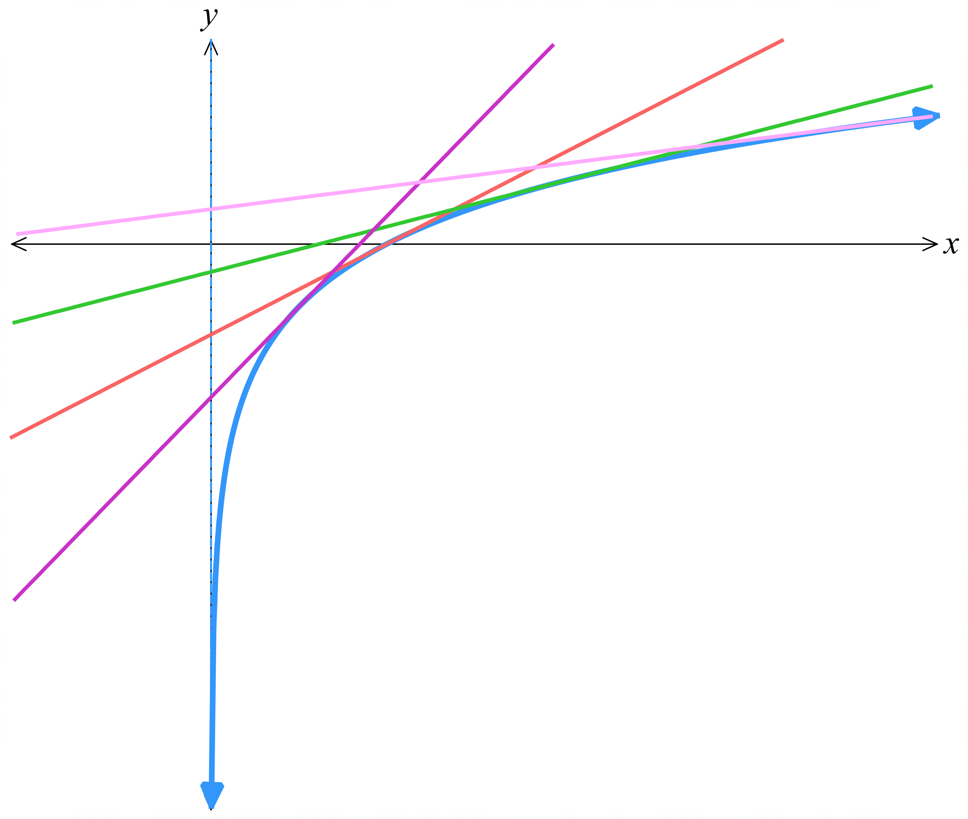
  - Draw a sketch of the curve and the four tangents, showing the angles of inclination.

- Differentiate these functions using the product rule.
- $x \log_{e} x$  $$y^{'}= log_{e}x + x\left(\frac{1}{x}\right)$$  $$= 1 + log_{e}x$$ | - $x log_{e}(2x + 1)$  $$y^{'}= log_{e}\left(2x + 1\right)+ x\left(\frac{2}{2x + 1}\right)$$  $$=\frac{2x}{2x + 1}+ log_{e}\left(2x + 1\right)$$
- $\left(2x + 1\right)\log_{e} x$  $$y^{'}= 2 log_{e} x + \left(2x + 1\right)\left(\frac{1}{x}\right)$$  $$=\frac{2x + 1}{x}+ 2 log_{e} x$$ | - $x^{4} \log_{e} x$  $$y^{'}=4x^{3}\log_{e}{x}+ x^{4}\left(\frac{1}{x}\right)$$  $$= x^{3}\left(1 + 4 log_{e}x\right)$$
- $\left(x + 3\right) \log_{e}(x + 3)$  $$y' = \log_{e}(x + 3) + \left(x + 3\right)\left(\frac{1}{x + 3}\right)$$  $$= log_{e}(x + 3) + 1$$ | - $\left(x - 1\right) \log_{e}(2x + 7)$  $$y^{'}= log_{e}\left(2x + 7\right)+ \left(x - 1\right)\left(\frac{2}{2x + 7}\right)$$  $$=\frac{2\left(x - 1\right)}{2x + 7}+ log_{e}\left(2x + 7\right)$$
- $e^{x} \log_{e} x$  $$y^{'}= eˣ log_{e} x + eˣ\left(\frac{1}{x}\right)$$  $$= eˣ\left(\frac{1}{x}+ log_{e} x\right)$$ | - $e^{-x} \log_{e} x$  $$y^{'}= -e^{-}ˣ log_{e} x + e^{-}ˣ\left(\frac{1}{x}\right)$$  $$= e^{-}ˣ\left(\frac{1}{x}- log_{e} x\right)$$
- Differentiate these functions using the quotient rule.
- $y =\frac{\log_{e} x}{x}$  $$y^{'}=\frac{x\left(\frac{1}{x}\right)- log_{e} x\left(1\right)}{x^{2}}$$  $$=\frac{1 - log_{e} x}{x^{2}}$$ | - $y =\frac{\log_{e} x}{x^{2}}$  $$y^{'}=\frac{x^{2}\left(\frac{1}{x}\right)- log_{e} x\left(2x\right)}{x^{4}}$$  $$=\frac{1 - 2log_{e} x}{x^{3}}$$
- $y =\frac{x}{\log_{e} x}$  $$y^{'}=\frac{log_{e} x\left(1\right)- x\left(\frac{1}{x}\right)}{{\left(log_{e} x\right)}^{2}}$$  $$=\frac{log_{e} x - 1}{{\left(log_{e} x\right)}^{2}}$$ | - $y =\frac{x^{2}}{\log_{e} x}$  $$y^{'}=\frac{log_{e} x\left(2x\right)- x^{2}\left(\frac{1}{x}\right)}{{\left(log_{e} x\right)}^{2}}$$  $$=\frac{x\left(2log_{e} x - 1\right)}{{\left(log_{e} x\right)}^{2}}$$
- $y =\frac{\log_{e} x}{e^{x}}$  $$y^{'}=\frac{eˣ\left(\frac{1}{x}\right)- log_{e} x\left(eˣ\right)}{e^{2}ˣ}$$  $$=\frac{1 - x log_{e} x}{xeˣ}$$ | - $y =\frac{e^{x}}{\log_{e} x}$  $$y^{'}=\frac{log_{e} x\left(eˣ\right)- eˣ\left(\frac{1}{x}\right)}{{\left(log_{e} x\right)}^{2}}$$  $$=\frac{eˣ\left(x log_{e} x - 1\right)}{x{\left(log_{e} x\right)}^{2}}$$

- Use the log laws to simplify each function, then differentiate it.
- $y = \log_{e}5x^{3}$  $$y = log_{e} 5 + 3log_{e} x,$$  $$y^{'}=\frac{3}{x}$$ | - $y = \log_{e}\sqrt[3]{x}$  $$y = \left(\frac{1}{3}\right)log_{e} x,$$  $$y^{'}=\frac{1}{3x}$$ | - $y = \log_{e}\left(\frac{3}{x}\right)$  $$y = log_{e} 3 - log_{e} x,$$  $$y' = -\frac{1}{x}$$
- $y = ln \sqrt{2 - x}$  $$y =\frac{1}{2}\ln\left(2 - x\right),$$  $$y^{'}= -\frac{1}{2\left(2 - x\right)}=\frac{1}{2x - 4}$$ | - $y = \log_{e}\left(\frac{3}{x}\right)$  $$y = log_{e} 3 - log_{e} x$$  $$y^{'}=\frac{1}{1 + x}+\frac{1}{1 - x}$$ | - $y = ln\left(\frac{1 + x}{1 - x}\right)$  $$y =\ln\left(1 + x\right)-\ln\left(1 - x\right),$$  $$y^{'}=\frac{1}{1 + x}+\frac{1}{1 - x}$$
- $y = \log_{e}2^{x}$  $$y = x log_{e}2,$$  $$y^{'}= log_{e}2$$ | - $y = \log_{e}e^{x}$  $$y = x,$$  $$y' = 1$$ | - $y = \log_{e}x^{x}$  $$y = x\log_{e}{x},$$  $$y' = 1 + log_{e} x$$

Mastery

  - Find the tangent to $y = ln x$ at $P(e, 1)$, and prove that it passes through O.
$$y = ln x,\frac{dy}{dx}=\frac{1}{x}$$
$$At P\left(e, 1\right): gradient =\frac{1}{e}$$
$$Tangent: y - 1 = \left(\frac{1}{e}\right)\left(x - e\right)$$
$$y = \left(\frac{1}{e}\right)x$$
Passes through $O(0, 0)$ as equation is of the form $y=kx$
  - Find the tangent to $y = ln x$ at $Q(1, 0)$, and prove that it passes through $A(0, -1)$.
$$At Q\left(1, 0\right): gradient =\frac{1}{1}= 1$$
$$Tangent: y - 0 = 1\left(x - 1\right)$$
$$y = x - 1$$
Equation is true when $x = 0$, $y = -1$, passes through A(0, -1)
  - Find the tangent to $y = ln x$ at $R\left(\frac{1}{e}, -1\right)$, and prove that it passes through $B(0, -2)$.
$$At R\left(\frac{1}{e}, -1\right): gradient =\frac{1}{\frac{1}{e}}= e$$
$$Tangent: y - (-1) = e\left(x -\frac{1}{e}\right)$$
$$y + 1 = ex - 1$$
$$y = ex - 2$$
$$When x = 0, y = -2, passes through B(0, -2)$$
  - Find the normal to $y = ln x$ at $A(1, 0)$, and its $y$-intercept.
$$At A(1, 0): gradient of tangent = 1$$
$$Normal has gradient = -1$$
$$Normal: y - 0 = -1(x - 1)$$
$$y = -x + 1$$
$$y intercept is 1$$

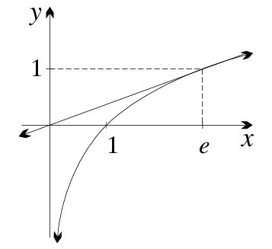
  - In the previous question you showed that the tangent at $P(e, 1)$ on the curve $y = ln x$ passes through the origin. Sketch the graph, showing the tangent, and explain graphically why no other tangent passes through the origin.

As P moves left along the curve, the tangent becomes steeper, so it does not pass through the origin.
As P moves right, the angle of the tangent becomes less steep, hence it does not pass through the origin.
  - Arguing from the graph, classify the points in the plane according to whether 0, 1 or 2 tangents pass through them.
0 tangents: all points below the curve
1 tangent: points on the curve, and points on or above the curve to the left of the y-axis
2 tangents: points above the curve and right of the y-axis
- Find, giving answers in the form $y = mx + b$, the equations of the tangent and normal to:
  - $y=4 ln x$ at the point $Q(1, 0)$
$$\frac{dy}{dx}=\frac{4}{x}$$
$$At Q\left(1, 0\right): gradient = 4$$
$$Tangent: y = 4x - 4$$
$$Normal: y=-\frac{x}{4} +\frac{1}{4}$$
  - $y=ln x+3$ at the point $R(1, 3)$
$$\frac{dy}{dx}=\frac{1}{x}$$
$$At R\left(1, 3\right): gradient = 1$$
$$Tangent: y = x + 2$$
$$Normal: y = -x + 4$$
  - $y=2 ln x-2$ at the point $S(1, -2)$
$$\frac{dy}{dx}=\frac{2}{x}$$
$$At S(1, -2): gradient = 2$$
$$Tangent: y = 2x - 4$$
$$Normal: y = -\frac{1}{2}x -\frac{1}{2}$$

  - Show that the point $P(1, 0)$ lies on the curve $y=ln(3x - 2)$.
$$When x = 1: y = ln(3(1) - 2) = ln 1 = 0$$
$P(1, 0)$lies on curve
  - Find the equations of the tangent and normal at $P$, and their $y$-intercepts.
$$\frac{dy}{dx}=\frac{3}{3x - 2}$$
$$At P\left(1, 0\right): gradient =\frac{3}{1}= 3$$
$$Tangent: y = 3x - 3$$
$$y intercept: -3$$
$$Normal: y = -\frac{1}{3}x +\frac{1}{3}$$
$$y intercept:\frac{1}{3}$$
  - Sketch the situation and find the area of the triangle formed by the tangent, the normal and the $y$-axis.
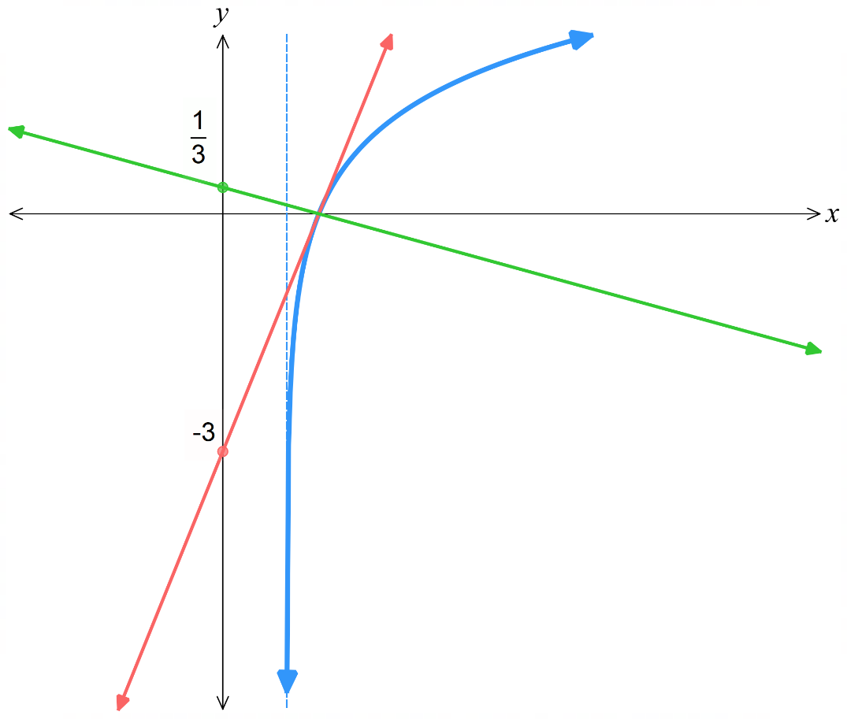

$$Area =\frac{bh}{2}=\frac{\left(\frac{1}{3}+3\right)(1)}{2}=\frac{5}{3} square units$$

- Differentiate each function using the chain, product or quotient rules.
Then find any values of x for which the derivative is zero.
- $y = x ln x - x$  $$y^{'}=\ln{x}+ x\left(\frac{1}{x}\right)- 1 = ln x$$  $$\ln{x}= 0,$$  $$x = 1$$ | - $y = x² ln x$  $$y^{'}= 2x\ln{x}+ x^{2}\left(\frac{1}{x}\right)= x\left(1 + 2ln x\right)$$  $$1 +2\ln{x}= 0,$$  $$x = e^{-\frac{1}{2}}$$
- $y =\frac{ln x}{x}$  $$y^{'}=\frac{1 - ln x}{x^{2}}$$  $$1 -\ln{x}= 0,$$  $$x = e$$ | - $y = (ln x)⁴$  $$y^{'}= 4{\left(ln x\right)}^{3}\left(\frac{1}{x}\right)=\frac{4{\left(ln x\right)}^{3}}{x}$$  $$\ln{x}= 0,$$  $$x = 1$$
- $y = (2 ln x - 3)⁴$  $$y^{'}= 4{\left(2ln x - 3\right)}^{3}\left(\frac{2}{x}\right)=\frac{8{\left(2ln x - 3\right)}^{3}}{x}$$  $$2\ln{x}- 3 = 0,$$  $$x = e^{\frac{3}{2}}$$ | - $y =\frac{1}{ln x}$  $$y' = -\frac{1}{x{\left(ln x\right)}^{2}}$$  Never zero
- $y = ln(ln x)$  $$y^{'}=\frac{1}{x ln x}$$  Never zero | - $y = x ln x$  $$y' = 1 + ln x$$  $$\ln{x}= -1,$$  $$x =\frac{1}{e}$$

- Find the coordinates of the point on $y=ln x$ where the tangent has gradient $\frac{1}{2}$.
Then find the equation of the tangent and normal there, in the form $y=mx + b$.
$$\frac{dy}{dx}=\frac{1}{x}=\frac{1}{2}$$
$$x = 2, y = ln 2$$
$$Point: (2, ln 2)$$
$$Tangent: y - ln 2 = \left(\frac{1}{2}\right)\left(x - 2\right)$$
$$y =\frac{1}{2}x - 1 + ln 2$$
$$Normal: y - ln 2 = -2\left(x - 2\right)$$
$$y = -2x + 4 + ln 2$$

Derivative of Logarithmic Functions of Any Base

- Investigation Derivative of logarithmic functions of any base.
We can change the base of any logarithm to base $e$ using the change of base law$:$
$$\log_{a}{x}=\frac{\ln{x}}{\ln{a}}$$
We can then differentiate, as $\ln{a}$ is a constant.
Differentiate:
$$f\left(x\right)=\log_{10}{x}$$

$f^{'}\left(x\right)=$

$$f\left(x\right)=\log_{2}{x}$$

$f^{'}\left(x\right)=$

$$f\left(x\right)=\log_{17}{x}$$

$f^{'}\left(x\right)=$

- Derivative of Logarithms of Any Base
$$y=\log_{a}{x} \\ \frac{dy}{dx}=\frac{1}{x(\ln{a})}$$

- Identify the derivative of a logarithmic function.
$f\left(x\right)=\log_{5}{x}$  $$f^{'}\left(x\right)=\frac{1}{x\ln{5}}$$ | $f\left(x\right)=\log_{8}{x}$  $$f^{'}\left(x\right)=\frac{1}{x\ln{8}}$$ | $$f\left(x\right)=\log_{52}{x}$$  $$f^{'}\left(x\right)=\frac{1}{x\ln{52}}$$
Differentiate these functions.
- $f\left(x\right)=\log_{11}{x}$ | - $f\left(x\right)=\log_{62}{x}$ | - $f\left(x\right)=\log_{\frac{3}{4}}{x}$
- $f\left(x\right)=\log_{e}{x}$ | - $f\left(x\right)=7\log_{2}{x}$ | - $f\left(x\right)=11\log_{5}{x}$

- Investigation Chain rule for logarithmic functions of any base.
Consider $y=\log_{a}\left(f\left(x\right)\right)$
Using chain rule, find the general form of the derivative.
$$y=\log_{a}\left(f\left(x\right)\right)$$
$$\frac{dy}{dx}=\frac{dy}{du}×\frac{du}{dx}$$
Let $u=f\left(x\right)$
$$\frac{du}{dx}=$$

Let $y=\log_{a}{u}$
$$\frac{dy}{du}=$$

- Chain Rule for Logarithms of Any Base
$$y=\log_{a}{f\left(x\right)} \\ \frac{dy}{dx}=\frac{f^{'}\left(x\right)}{\left(\ln{a}\right)f\left(x\right)}$$

- Identify the derivative of a logarithmic function.
$f\left(x\right)=\log_{5}\left(2x\right)$  $$f^{'}\left(x\right)=\frac{2}{\left(\ln{5}\right)\left(2x\right)}$$ | $f\left(x\right)=\log_{5}\left(2x+7\right)$  $$f^{'}\left(x\right)=\frac{2}{\left(\ln{5}\right)\left(2x+7\right)}$$ | $$f\left(x\right)=\log_{7}\left(x^{3}-7x\right)$$  $$f^{'}\left(x\right)=\frac{3x^{2}-7}{(\ln{7})\left(x^{3}-7x\right)}$$
Differentiate these functions.
- $f\left(x\right)=\log_{3}\left(7x\right)$ | - $f\left(x\right)=\log_{3}\left(7x-3\right)$ | - $f\left(x\right)=\log_{11}\left(x^{4}\right)$
- $f\left(x\right)=\log_{12}\left(3x^{2}+5\right)$ | - $f\left(x\right)=\log_{7}\left(\sqrt{x}\right)$ | - $f\left(x\right)=\log_{12}\left(\frac{1}{x}\right)$

Foundation
- Use the change-of-base formula to express these with base $e$, then differentiate them.
- $y = log₂ x$  $$y =\log_{2}{x} =\frac{ln x}{ln 2}$$  $$y^{'}=\frac{1}{x ln 2}$$ | - $y = log₁₀ x$  $$y =\log_{10}{x} =\frac{ln x}{ln 10}$$  $$y^{'}=\frac{1}{x ln 10}$$ | - $y = 3log₅ x$  $$y =3\log_{5}{x}=\frac{3ln x}{ln 5}$$  $$y^{'}=\frac{3}{x ln 5}$$

- Differentiate using the formula:
- $y = log₃ x$  $$y^{'}=\frac{1}{x ln 3}$$ | - $y = log₇ x$  $$y^{'}=\frac{1}{x ln 7}$$ | - $y = 5log₆ x$  $$y^{'}=\frac{5}{x ln 6}$$

  - Differentiate $y$ = log₂ $x$. Hence find the gradient of the tangent to the curve at $x = 1$.
$$y =\log_{2}{x}, y^{'}=\frac{1}{x ln 2}$$
$$At x = 1: gradient =\frac{1}{\ln{2}}$$
  - Hence find the equation of the tangent there.
$$At x = 1: y = log₂ 1 = 0$$
$$Tangent: y - 0 = \left(\frac{1}{\ln{2}}\right)\left(x - 1\right)$$
$$y =\frac{\left(x - 1\right)}{\ln{2}}$$
- Find $f^{'}\left(1\right)$ if $f(x) = ln \sqrt{2 - x}.$
$$f^{'}\left(x\right)= \left(\frac{1}{2}\right)\left(-\frac{1}{2 - x}\right)= -\frac{1}{2\left(2 - x\right)}$$
$$f^{'}\left(1\right)= -\frac{1}{2\left(1\right)}= -\frac{1}{2}$$

  - Find the equation of the tangent to $y=\log_{10}{x}$ at $\left(10,1\right)$
$$y^{'}=\frac{1}{x ln 10}$$
$$At x = 10: gradient =\frac{1}{10 ln 10}$$
$$At x = 10: y = 1$$
$$Tangent: y - 1 = \left(\frac{1}{10 ln 10}\right)\left(x - 10\right)$$
$$x - 10y ln 10 - 10 + 10 ln 10 = 0$$
$$x - 10y ln 10 + 10\left(ln 10 - 1\right)= 0$$

  - At what value of $x$ will the tangent have gradient 1?

$$\frac{1}{x ln 10}= 1$$
$$x =\frac{1}{\ln{10}}$$

